Problem Set 2

Nana Li, Keqi Meng, Zhaoyang Chen

Question 1

1. Suppose that the yield curve will remain unchanged for the following five years and you have decided to use bond A to fund the liability. That is, you want to invest in bond A and invest the coupons at the prevailing interest rates to produce a future value at the end of year five of 1 million. How much should you invest in bond A?

Yield to maturity = 10%

Suppose invest x bond A, then

15X(1+10%)4 + 15X(1+10%)3 + 15X(1+10%)2 +15X(1+10%)+ (100+15)X = 1000,000

X = 5219.85

So I should invest 5219.85 bond A or 5219.85 \* 118.95 = $620,901.16 in bond A.

1. Now suppose that right after you invested in bond A, the yield curve makes a parallel move down by 1% to 9%. What is the future value five years from now of your investment? What is the future value if the yield curve moves up by 1% to 11%? Please explain why the future value changes differently depending on the direction of the change in the yield curve.

Yield to maturity = 9%

FV5 = 15 X 5219.85 X (1+9%)4 + 15 X 5219.85 X (1+9%)3 + 15 X 5219.85 X (1+9%)2 +15 X 5219.85 X (1+ 9%)+ (100+15) X 5219.85 = $990,574.38

∆FV = $9,425.62

Yield to maturity = 11%

FV5 = 15 X 5219.85 X (1+11%)4 + 15 X 5219.85 X (1+11%)3 + 15 X 5219.85 X (1+11%)2 +15 X 5219.85 X (1+ 11%)+ (100+15) X 5219.85 = $1,009,607.84

∆FV = $9607.84

With a parallel shift, when the yield curve is shifting up, the change in FV in multiple periods will be higher than the change in FV in multiple periods if the yield curve is shifting down by the same amount because of the compounding effect.

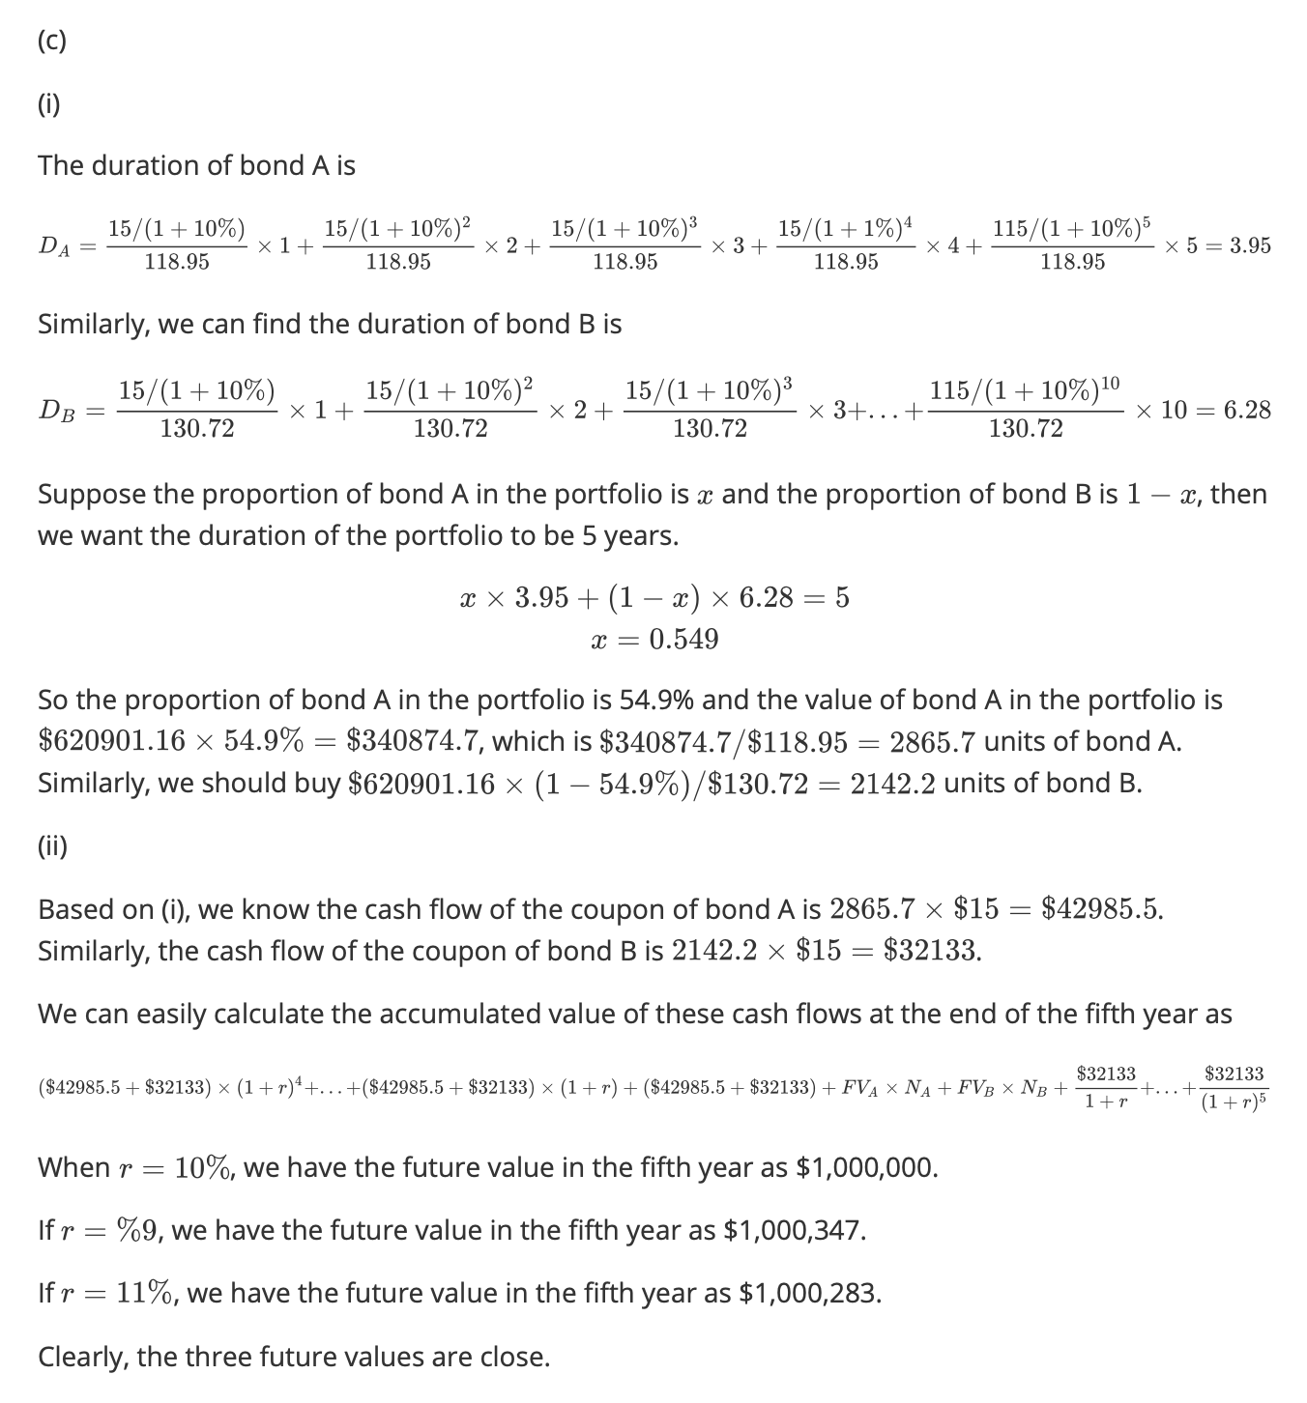

(c). iii

At the end of Year 1:

Bond A Duration is 3.35 years

Bond B Duration is 5.98 years

FV of Bond B at the end of Year 5 with 9% yield is equal to $123.34

Assume we will purchase A bond A and B bond B, solve for the follow equations:

(15A + 15B)\*1.09^3 + (15A +15B)\*1.09^2 + (15A +15B)\*1.09 + (15A + 15B) + 100A + 123.34B = 1,000,000

And

3.35\*A/(A+B) + 5.98\*B/(A+B) = 4

We get A = 4,319.07; B = 1,416.09

If yield changes to 10%, FV of Bond B will change to $118.95, and at the end of Year 5 we will receive:

(15A + 15B)\*1.1^3 + (15A +15B)\*1.1^2 + (15A +15B)\*1.1 + (15A + 15B) + 100A + 118.95B, which equals to $999,604, approximately $1,000,000

If yield changes to 8%, FV of Bond B will change to $127.95, and at the end of Year 5 we will receive:

(15A + 15B)\*1.1^3 + (15A +15B)\*1.1^2 + (15A +15B)\*1.1 + (15A + 15B) + 100A + 118.95B, which equals to $1,000,736, approximately $1,000,000